Given a binary tree where each path going from the root to any leaf form a **valid sequence**, check if a given string is a **valid sequence** in such binary tree.

We get the given string from the concatenation of an array of integers arr and the concatenation of all values of the nodes along a path results in a **sequence** in the given binary tree.

**Example 1:**

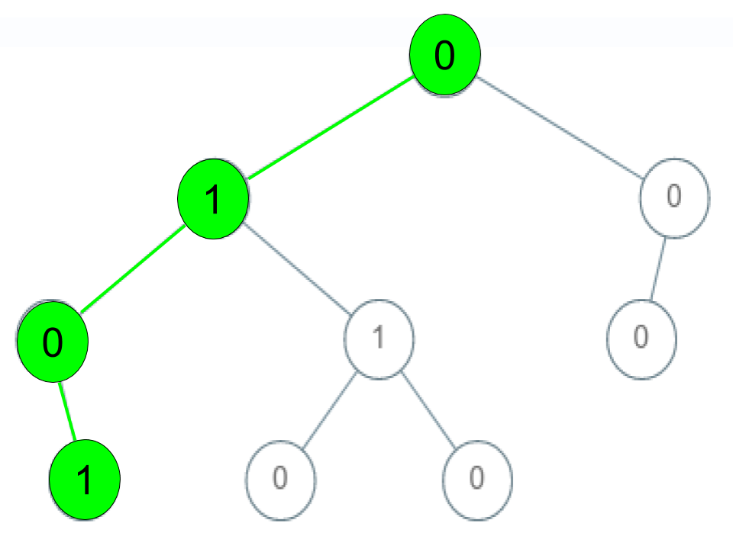

**Input:** root = [0,1,0,0,1,0,null,null,1,0,0], arr = [0,1,0,1]

**Output:** true

**Explanation:**

The path 0 -> 1 -> 0 -> 1 is a valid sequence (green color in the figure).

Other valid sequences are:

0 -> 1 -> 1 -> 0

0 -> 0 -> 0

**Example 2:**

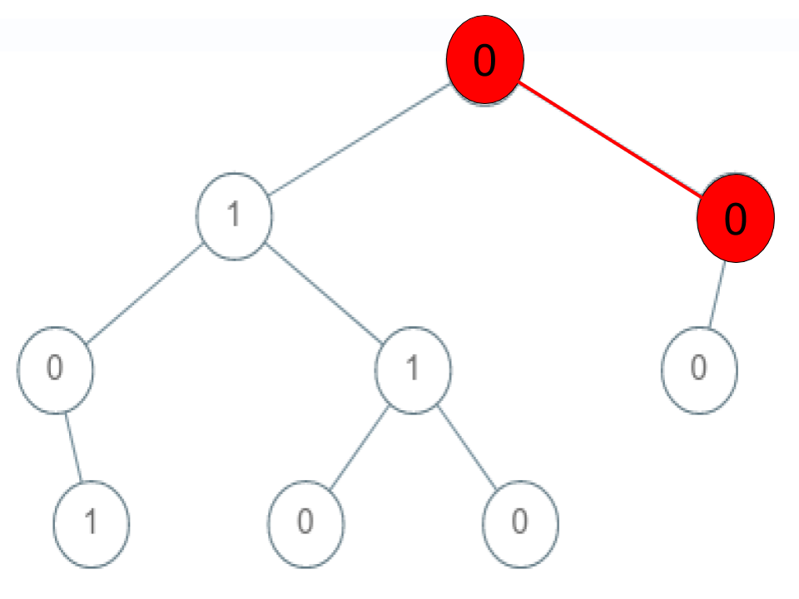

**Input:** root = [0,1,0,0,1,0,null,null,1,0,0], arr = [0,0,1]

**Output:** false

**Explanation:** The path 0 -> 0 -> 1 does not exist, therefore it is not even a sequence.

**Example 3:**

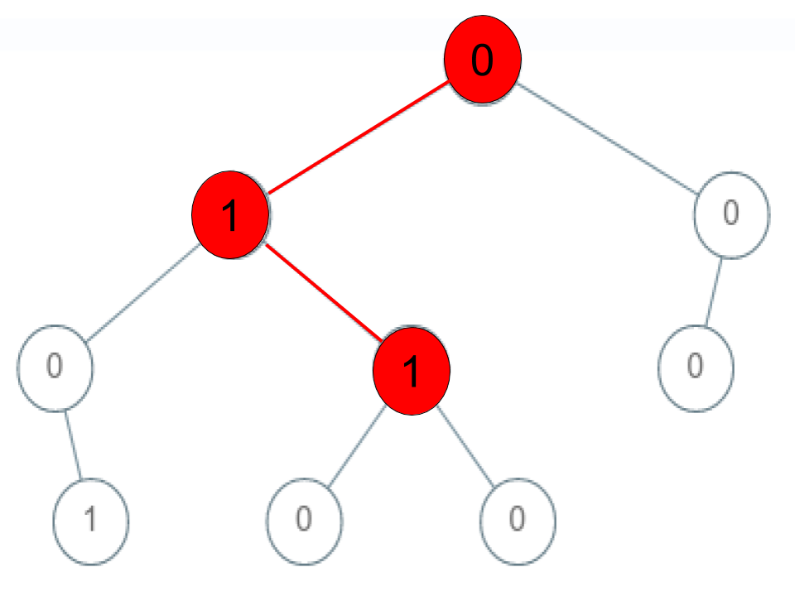

**Input:** root = [0,1,0,0,1,0,null,null,1,0,0], arr = [0,1,1]

**Output:** false

**Explanation:** The path 0 -> 1 -> 1 is a sequence, but it is not a valid sequence.

**Constraints:**

* 1 <= arr.length <= 5000
* 0 <= arr[i] <= 9
* Each node's value is between [0 - 9].